Boston University
Summer Challenge
Summer 2012

Smart Lighting

Originally by Thomas Little, tdcl@bu.edu, 617-353-9877, PHO 426
with contributions from Tarik Borogovac, tarikb@bu.edu, 617-353-0161

Edited by Jimmy C. Chau, jchau@bu.edu, 617-353-8042

hulk.bu.edu/courses/SmartLight

Syllabus

Instructor
- Mr. Jimmy Chau - jchau@bu.edu - PHO445 - (617) 353-8042
- Mr. Gregary Prince - gbprince@bu.edu - PHO445 - (617) 353-8042

Teaching Assistants
- Lucy Yan – lucytyan@bu.edu
- Matthew Heller-Wallace – five8two@bu.edu
- Johnny Glynn – jglynn1@bu.edu

Website for materials: hulk.bu.edu/courses/SmartLight/

Course Objectives
- To introduce students to the electronics components, circuits, signals and tools
- To familiarize students with LED technology
- To familiarize students with visible light communications with LEDs
- To inform students about contemporary events in the LED and general lighting industries
- To develop engineering communication skills

Course Outcomes
As an outcome of completing this course, students will be able to:
- Use the Rhett Board for electronic test measurement and signal generation
- Build and characterize LED and photodiode circuits
- Measure LED electrical and optical characteristics
- Apply digital and analog modulation to create an optical channel
- Assemble a functioning prototype
- Prepare written engineering reports, memos, and logbooks
- Work effectively with a teammate on a design problem
- Appreciate and identify leading sources of technical industry news
- Present a technical explanation of an engineering project

Schedule

Module | Topic | Activities
0 | Introduction | Introduction, overview of course, Smart Lighting
1 | Rhett Board | The Rhett board and signals
2 | Circuits | Resistor and capacitors circuits
3 | Driving LEDs | LED current/voltage characteristic
4 | Light | Building a photodetector and assessing the light channel
5 | Data communication | Linking LEDs to photodetector
6 | Building a Transceiver | PCB prototype assembly
7 | Analog modulation | Analog data (sound) transmission
8 | Signaling with light | Digital data transmission
9 | Digital Transceiver | Characterizing and using prototype transceiver board
10 | Light spectrum | CD Spectrometer
11 | Heart Monitor | Acoustic signal detection
12 | Presentations | Student presentation of topics
13 | Summary | Open Discussion

Rules
- Work in assigned teams (two or three people)
- Keep a good individual logbook
- Work with and help your teammate
- Collaborate with other teams
- Tinkering/experimenting with the tools and components is good
- The modules may change depending on the progress of the class

Lab Books

Please keep a lab book to record what you do in the class. It will be your reference to what you accomplish in each lab.

What to write in the lab book:

Key entries:
- Name
- Date of entry
- What you did
- Observations
- Sketches of lab setup
- Calculations
- Data
- Results

But, some lab books are better than others…

Good:
- All of the above

Better:
- Consistency in entries
- Legible
- Organized

Having more detail will allow you to go back and reproduce earlier results, and be able to make claims against results that you obtained.

Lab Module 0: The Smart Lighting Lab Kit

See:
- Course web site: http://hulk.bu.edu/courses/SmartLight/
- The Mobile Studio Project: http://www.mobilestudioproject.com/

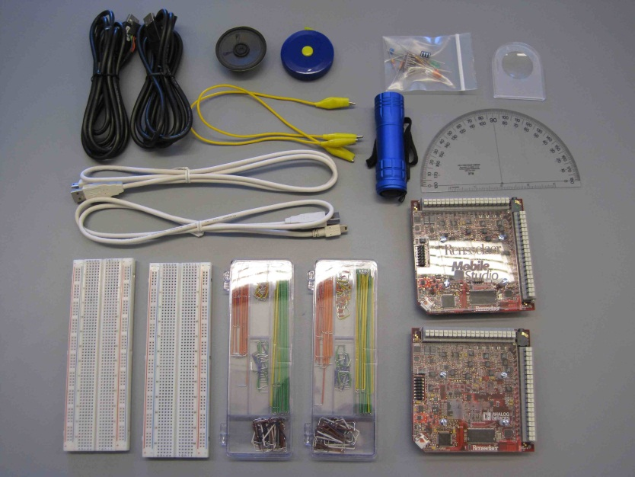
Figure 1: Kit Contents

Lab kit contents:
- 2 Rhett Boards
- 2 USB to micro-USB cables
- 2 Breadboards
- 2 Wiring kits
- Resistors, capacitors
- Red, white, green LEDs
- Photodiode
- Operational amplifiers (op-amps)
- XOR gate
- Lens
- Flashlight
- Tape measure
- Protractor
- Speaker
- Transceiver printed circuit board (PCB)
  - Board Components
  - 2 USB to serial (FTDI) cables

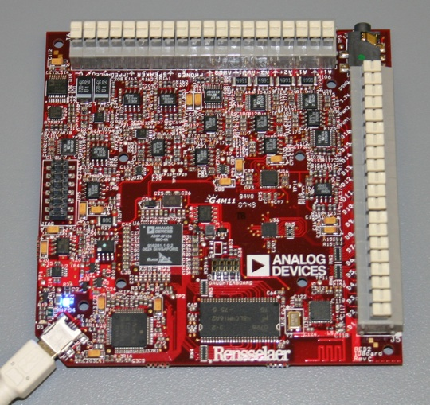
Figure 2: The Rhett Board

Pin-out of the Rhett Board

Bank 1
-V: -4V DC (capable of providing ~ 50mA)
+V: +4V DC (capable of providing ~ 50mA)
Impedance Analyzer + (not yet released)
Impedance Analyzer - (not yet released)
GND: analog ground
Speaker -: Audio Out
Speaker +: Audio Out
GND: analog ground
Phones R : Audio Out Right Channel
Phones L : Audio Out Left Channel
GND : analog ground
AWG2 : Arbitrary Waveform Generator Channel 2 (Same as FG 2)
GND : analog ground
AWG1 : Arbitrary Waveform Generator Channel 1 (Same as FG 1)
A2- : Analog Channel 2 Input (- side of differential front end)
GND : analog ground
A2+ : Analog Channel 2 Input (+ side of differential front end)
A1- : Analog Channel 1 Input (- side of differential front end)
GND : analog ground
A1+ : Analog Channel 1 Input (+ side of differential front end)

Bank 2:
Digital I/O 1 - 16 : Digital Input/Output
PWM1 : Pulse Width Modulation Channel 1
PWM2 : Pulse Width Modulation Channel 2
3.3V : +3.3v DC (used for the digital portion of the board)
DGND : digital ground

The Rest of the Kit

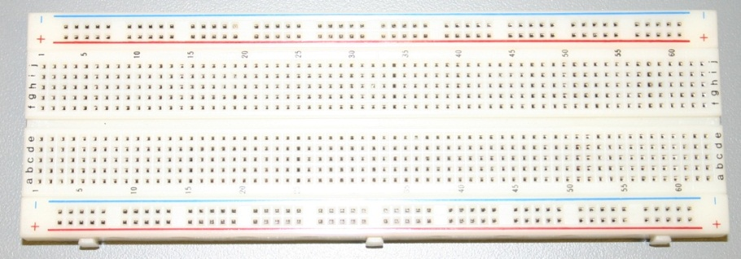
Figure 3: Breadboard

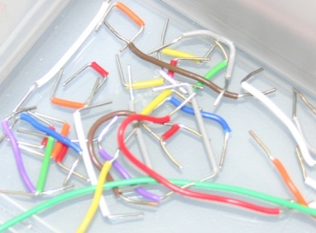
Figure 4: Jumper Wires

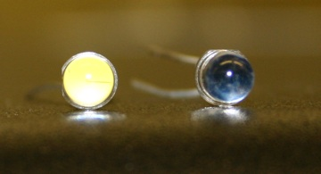
Figure 5: LED (left) and Photodiode (right)

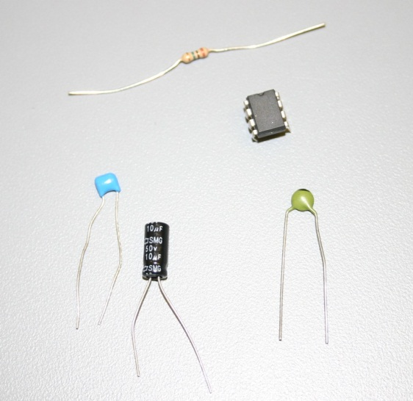
Figure 6: Resistor, Capacitors, and Op-Amp

Lab Module 1: the Rhett Board – Kicking the Tires

Objective: This lab is all about familiarization with the Rhett Board. This unit is a USB-based data input/output board which can serve as a variety of electronic laboratory equipment, including a function generator and an oscilloscope. In this exercise we will learn about the hardware and explore its features and software environment via a set of demonstrations and basic experiments. Later, we will use the Rhett Board to investigate LED light and wireless optical communications.

Key terms and units
Rhett Board: What we call the data acquisition board unit
Oscilloscope: A device for displaying electrical signals that vary over time
Function Generator: A device for creating time varying electrical signals

Background reading
- Voltage: http://simple.wikipedia.org/wiki/Voltage
- Frequency and wavelength: http://en.wikipedia.org/wiki/Frequency
- Oscilloscope: http://en.wikipedia.org/wiki/Oscilloscope
- Spectrum Analyzer: http://en.wikipedia.org/wiki/Spectrum_analyzer
- Harmonic: http://en.wikipedia.org/wiki/Harmonic
- Square wave: http://en.wikipedia.org/wiki/Square_wave
- Pulse-width modulation (PWM): http://en.wikipedia.org/wiki/Pulse-width_modulation

Figure 7: The Rhett Board

Rhett Board and Mobile Studio Setup:
- Find two adjacent computers in the lab. Each person should log into a machine next to your teammate(s).
- Check for the Mobile Studio Desktop icon. (Requires admin installation if not present.)
- Double click to start
- Unpack your lab kit with your team. Attach each Rhett board to a separate computer (it is possible to run multiple boards from a single computer but this is a less stable configuration). Note your board number and letter (1A, 1B, etc.).
- Plug your Rhett Board into the USB port. A blue light will turn on. If this is a first-time connection, you may need to install device drivers and upgrade firmware (see instructor or lab assistant).
- Likewise, if this is the first time that the board is paired with a computer, it will prompt you to calibrate it. Please download the appropriate calibration file onto your computer from the calibration folder on hulk. Then give the location of that file on your computer to Mobile Studio.
- A reference manual for the software is available on hulk in the folder “Reference Materials”

Software Orientation
Here we will walk through the various functions provided by Mobile Studio as an interface to the Rhett Board.

The main applications within Mobile Studio are labeled:
- Arbitrary Waveform: generates waveforms on output pins
- Digital I/O: send or receive logic one or zero signals on output pins
- Function Generator: generate regular waveforms (sine, square, triangle)
- Oscilloscope: graphic display and measurement of time varying inputs
- Spectrum Analyzer: graphic display and measurement of signals on frequency axis

Walk Through
Digital I/O
- Insert an LED from the kit into the pins: D1 and D2.
  - Use the Digital I/O application to toggle these two pins
  - Turn LED on/off
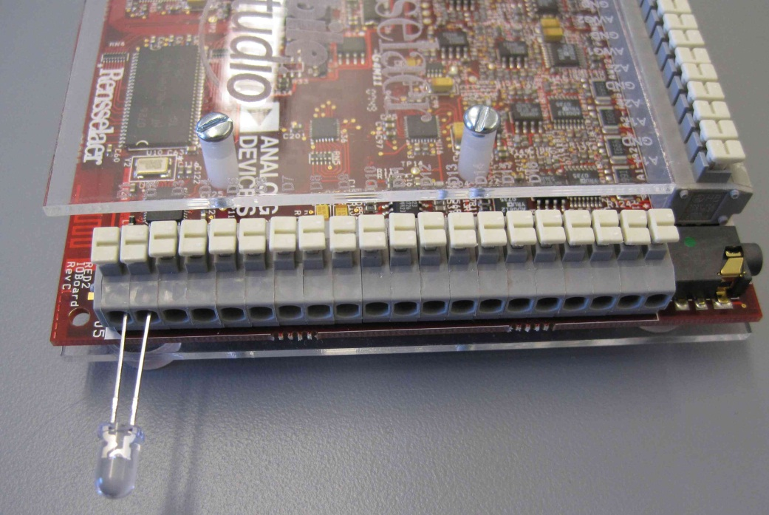

- Insert the LED into PWM1 and DGND (polarity matters here)
  - Use the PWM function to drive the LED on/off at different rates and duty cycles
  - As the frequency is increased, at what point does the on-off cycle become invisible?

Function Generator
- Create a sine wave at 10 kHz on AWG1 (channel 1)
- Create a sine wave shifted in phase by 90 degrees

Oscilloscope
- For Channel 1, set the input to AWG1, DC coupling
- Start the measurement (big green button)
- Observe the graphical output. Try the various controls that modify the result
  - Change timescale
  - Change signal amplitude scale
- Enable Channel 2, input to AWG2, DC coupling
  - Note phase differences of two signals

Team Exercises
- Using a jumper wire from the kit (a hardware, not a software connection), connect the digital I/O D1 to the oscilloscope channel 1 (A1). Show how the signal level can be switched from logic low to logic high

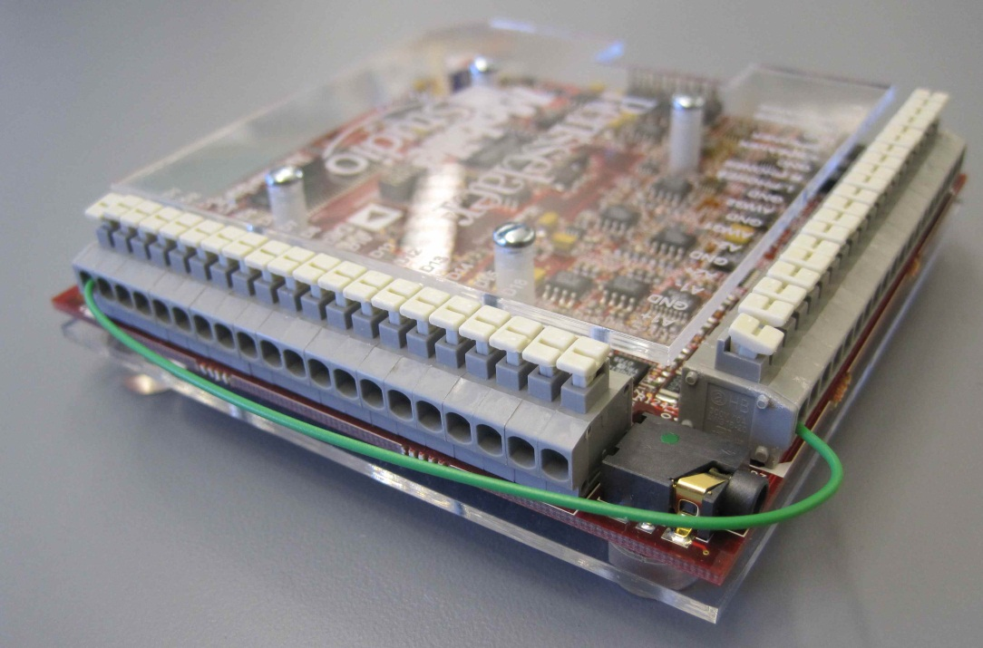

- Remove the jumper wire and connect a wire from PWM1 to A1. This connects the PWM signal to the input to the oscilloscope channel 1. Explore changes to the PWM signal displayed on the scope.

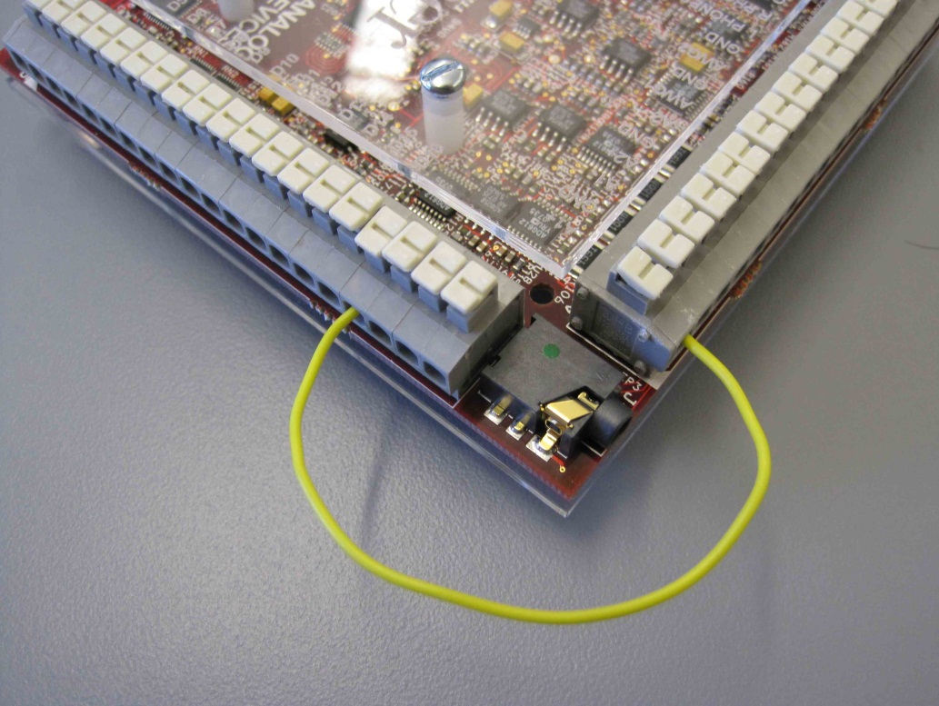

- Connect the function generator to the oscilloscope (what pins?). Show a square wave at 100Hz into the oscilloscope. Show a sine wave

- Switch to the spectrum analyzer. Use this tool to explore the frequency components of the input signal.
  - What are the frequency components of the sine wave?
  - Of the sawtooth wave?
  - Of the square wave?

- Back to the oscilloscope. Use the arbitrary waveform generator to create an output consisting of a sine wave at 1000Hz
  - Play this to the stereo jack (how?)
  - Add a second sine wave at 1000Hz but shifted in phase by 180 degrees. What does the combined signal look like?
  - Change the second sine wave to 999 Hz. What happens?

- Build up the harmonics
  - Switch back to a the first 1000Hz signal
  - Add a sine wave at 2000Hz and show the results in the spectrum analyzer and scope
  - Add a sine wave at 3000Hz
  - Add a sine wave at 4000 Hz

Smart Lighting
Lab Module 2: Circuits with LEDs

Objective: This lab is about LEDs, how to drive them, and some basic properties of electrical circuits.

Background reading
- Resistors: http://en.wikipedia.org/wiki/Resistor
- Resistor Color Code: http://en.wikipedia.org/wiki/Electronic_color_code
- Light Emitting Diodes (LEDs): http://en.wikipedia.org/wiki/LED
- LEDs (advanced): http://zone.ni.com/devzone/cda/ph/p/id/130
- Resistor-Capacitor (RC) Circuit: http://en.wikipedia.org/wiki/RC_circuit

Overview
- What is a circuit?
- Current, voltage, resistance, capacitance and mechanical analogs
  - Resistance – analogous to valve in shower
  - Voltage – analogous to pressure
  - Current – analogous to flow
  - Capacitance – analogous to a tank
  - Shower valve, tank, spigot analogy
- Voltage divider
- Effect of capacitance (tank) on variations in flow
  - Tank smooths out flow
  - Square wave
- Ohm’s law
- Reading a resistor value
- Wiring of the breadboard

Rhett Board and Mobile Studio Setup:
- Find two adjacent computers in the lab. Log into a machine next to your teammate(s). Note: only one Computer/Rhett Board is required, but each person can run the exercise.
- Setup your Rhett boards as you did in Module 1.

Team Exercises

- Exploring a resistor voltage divider circuit
  - Find the 1K ohm and 2.2K ohm resistors
  - Create a circuit with two resistors in series (this is a static circuit)
    - Use resistors of 1K ohm, 2.2K ohm
    - Input voltage of +3.3V DC (circuit between D1 and DGND)
    - Open the oscilloscope and set channel 1 to A1SE
    - Connect wires to A1+ and GND. Use these wires to probe the voltages at each point in the circuit using the Oscilloscope (see figure). Sketch your circuit and write down the voltage observed at each point in the circuit.

[Resistor circuit will be sketched on the whiteboard]

  - Calculate current expected through this system of resistors using Ohm’s Law
    - Put this in a table corresponding the test points.
  - Calculate the voltage across each resistor (again using Ohm’s law and the current just computed) and put in the table
  - Make sure that the digital output D1 is turned on (digital I/O panel)
  - Using A1+ as a test probe, measure each test point and tabulate.
    - Explain your results vs. your calculations

  - Optional
    - Add a parallel resistor, probe each point in the circuit and record the voltages

- Dynamic characteristics of the resistive circuit
  - Change the input to your circuit to be from the PWM1 output (instead of D1)
  - Drive a PWM square wave (1kHz, 50% duty cycle) into your circuit. What do you see on the scope? Capture a screen shot.
  - Capture the peak to peak voltages at frequencies in the data collection spreadsheet.

Frequency (Hz) | $$V_{{\left\{p-p\right\}}_{1}}$$ | $V_{{\left\{p-p\right\}}_{2}}$ | $V_{{\left\{p-p\right\}}_{3}}$ | $V_{{\left\{p-p\right\}}_{4}}$ | $V_{{\left\{p-p\right\}}_{5}}$Vp-p-5
1
10
100
1,000
10,000
100,000
- Static resistor-capacitor circuit
  - Create an RC circuit as shown in the illustration:
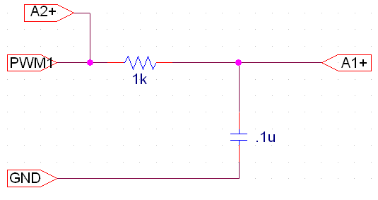
  - Use R = 1kΩ and C = 0.1µF

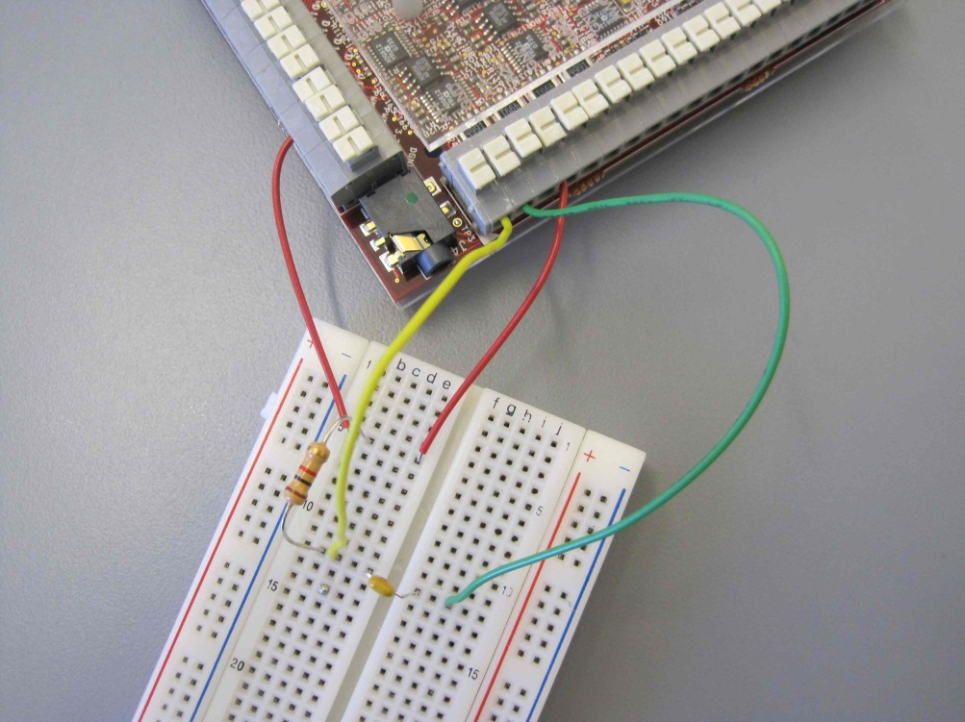

  - Start with a static circuit: use an input voltage as before +3.3V DC.
  - Probe the voltages at each point in the circuit using the Oscilloscope. Sketch your circuit and write down the voltage observed at each test point

- Dynamic resistor-capacitor circuit
  - Connect your circuit to the PWM1 (instead of +3.3V DC)
  - Connect the scope to A1+ for the capacitor output
  - Connect the scope to A2+ for the PWM1 signal
  - Drive a square wave at 1 kHz into your circuit on the PWM1
  - Display both channels of the scope (input PWM signal and output on the capacitor)
  - What are your observations?
  - Repeat for values in the table below, recording the peak to peak voltage
  - What is happening? What is the mean signal value?

Frequency (Hz) | $V_{{\left\{p-p\right\}}_{1}}$ | $V_{{\left\{p-p\right\}}_{2}}$ | $V_{{\left\{p-p\right\}}_{3}}$ | $V_{{\left\{p-p\right\}}_{4}}$ | $V_{{\left\{p-p\right\}}_{5}}$
1
10
100
1,000
10,000
100,000

Lab Module 3: Driving LEDs

Objective: This lab is about LEDs, how to drive them, and some basic properties of electrical circuits.

Background reading
- LEDs: http://en.wikipedia.org/wiki/LED
- Light Emitting Diodes (LEDs): http://zone.ni.com/devzone/cda/ph/p/id/130

Overview
- Electrical characteristics of LEDs
- Driving LEDs/LED circuit designs

Rhett Board and Mobile Studio Setup:
- Find two adjacent computers in the lab. Log into a machine next to your teammate(s). Note: only one Computer/Rhett Board is required, but each person can run the exercise.
- Setup your Rhett boards as in Module 1

Team Exercises

- Build circuit to display a current-voltage characteristic for one of our LEDs
  - Setup the circuit as shown in schematic, connecting wires to the proper pins on the Rhett Board
  - Open the ‘Function Generator’ tab
    - Set channel 1 to a 1kHz sine wave with 7V p-p and 0V DC offset (the LED should come on)
  - Open the ‘Oscilloscope’ tab
    - Channel X Settings:
      - Volts/Div: 2V
      - Coupling: DC
      - Input: A1 SE
    - Channel Y Settings:
      - Volts/Div: 2V
      - Coupling: DC
      - Input: A2 SE
    - Horizontal Settings
      - Time/Div: 1ms
      - Mode: X-Y
  - What is Vf?
  - Record a screenshot
  - What are the characteristics of the LED we are using?
  - How about the white LED?

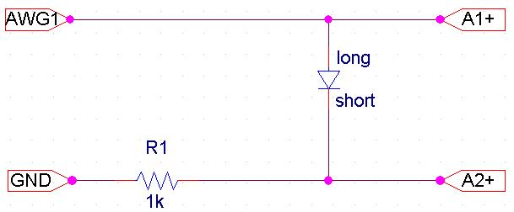

- Design circuit to power LED with DC input from fixed voltage (resistor in series)
  - Identify the anode and cathode of the LED.
  - What voltage and resistance do we need to achieve 30mA?
  - For the specs of the LEDs we use and a target power level of < 85mW .
  - What resistor will yield this LED power level.?
  - Build it.
  - How much power is wasted in this scheme?

- Design a circuit to power a LED with PWM
  - The Rhett Board current limits at 50mA. Power can be limited using a duty cycle.
  - What duty cycle can yield a power level of 17mW?
  - Implement your scheme using the PMW1 control.

Smart Lighting
Lab Module 4: Light, Spectrum, Wavelength, Luminosity

Objective: This lab is about light including what is produced by LEDs.

Background reading
- Visible Spectrum: http://en.wikipedia.org/wiki/Visible_spectrum
- Solar Radiation: http://en.wikipedia.org/wiki/Solar_radiation
- Power: http://en.wikipedia.org/wiki/Orders_of_magnitude_(power)
- Gain: http://en.wikipedia.org/wiki/Gain
- Lux: http://en.wikipedia.org/wiki/Lux
- Illuminance: http://en.wikipedia.org/wiki/Illuminance
- Luminosity: http://en.wikipedia.org/wiki/Luminosity
- Visible Spectrum: http://en.wikipedia.org/wiki/Visible_spectrum
- Color Rendering Index: http://en.wikipedia.org/wiki/Color_rendering_index
- Color Temperature: http://en.wikipedia.org/wiki/Color_temperature

Overview
- Light, spectrum, wavelength, luminosity
- Units of light
- Wavelengths of light
- Power, power measurement, gain

Rhett Board and Mobile Studio Setup:
- Find two adjacent computers in the lab. Log into a machine next to your teammate(s).
- Setup your Rhett boards as in Module 1

Team Exercises
- Setup
  - Setup one Rhett Board using a photodiode circuit as shown in the schematic below

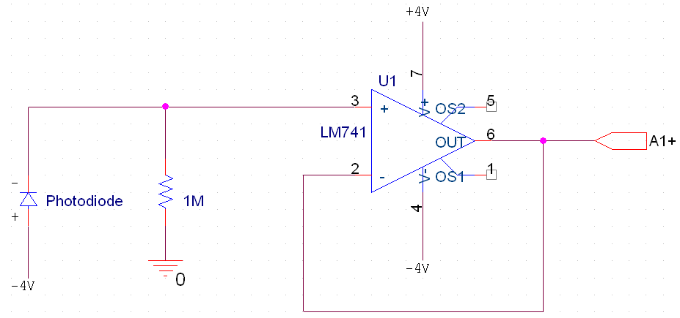

  - Connect the photodiode circuit to the A1+ and AGND pins and enable the oscilloscope on channel 1

- Qualitative Measurement
  - What is the ambient light level? Under what conditions should you measure this? Lights on? Monitor? Projector?
  - Determine the difference, as measured in gain (or loss) between different lighting scenarios.
  - Use the computer optical mouse as a light source. What are the characteristics of the light emitting from the mouse? Frequency? Intensity relative to ambient? At what distance?
  - What are the characteristics of the light reflecting from the projection screen?
  - What are the characteristics of the light from the fluorescent tubes overhead?

- Intensity with Distance: Using the flashlight and reference model shown below, measure, record, and plot the signal as follows:
  - Distances from 0 to 1m at increments of 10cm, then at 2m and 3m
  - Convert to gain (loss) using the spreadsheet on the web site
  - Experiment with lenses, reflectors, etc.
  - Observations? Performance?
Photodiode

- Intensity with Departure Distance from Center: Using the reference model below, measure, record, and plot the signal as follows:
  - At a distance of 1m, lateral deviations from 0 to 1m in increments of 10cm.
  - Convert to gain (loss) using the spreadsheet on the web site
Photodiode

- Design
  - Setup your LED on one Rhett Board using the AWG1 and AGND pins

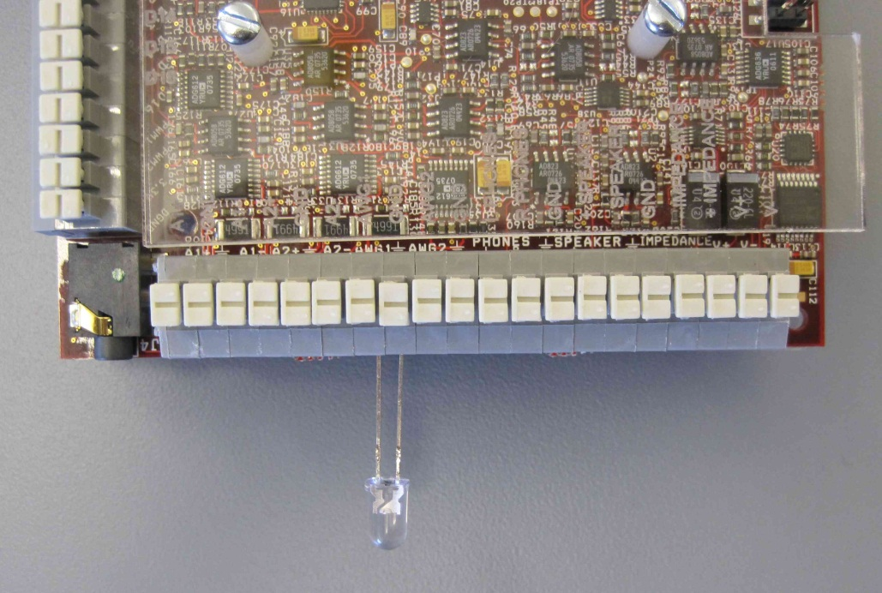

  - Point the LED at the photodiode at approx. 1m (the LED and photodiodes should be set up each on their own board. You should be able to see the optical waveform on the oscilloscope.
  - Observe the output via the spectrum analyzer. You should see a peak at 5kHz. Set the spectrum averaging to 16 to see better peaks.
  - Using the Arbitrary Waveform Generator, produce a sine wave at 5kHz with 1.5V peak-to-peak and 2.5V offset. This will drive a sine wave as an optical output.
  - This now can send sine-modulated light to the receiver.
  - As in the previous step, investigate the angles and distances at which the signal can be received.
  - What are your conclusions about how you might design a system that needs the best signal to the photodiode?

Lab Module 5: Data Communication

Objective: This lab is about interconnecting the LED with the photodiode to form a data communication channel using light.

Background reading
- Heliograph: http://en.wikipedia.org/wiki/Heliograph
- Flag Semaphore: http://en.wikipedia.org/wiki/Flag_semaphore
- Optical Communications: http://en.wikipedia.org/wiki/Optical_communication
- Free Space Optical Communications: http://en.wikipedia.org/wiki/Free_space_optical_communication

Overview
- Light, spectrum, wavelength, luminosity
- Units of light
- Wavelengths of light
- Power, power measurement, gain

Rhett Board and Mobile Studio Setup:
- Find two adjacent computers in the lab. Log into a machine next to your teammate(s).
- Setup your Rhett boards as in Module 1

Team Exercises
- Setup
  - Setup one Rhett Board using a photodiode circuit as per the previous module
  - Connect the breadboard to the Rhett Board (not plugged in yet)
  - Connect the photodiode circuit to the A1 and AGND pins and
  - Plug the Rhett Board into the USB port
  - Enable the oscilloscope on channel 1
  - The board should look like this when complete:

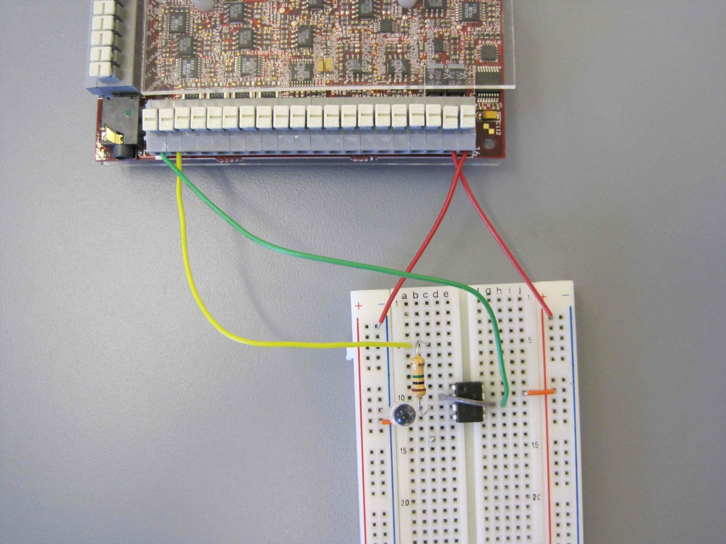

- Data Modulation
  - Setup your LED on one Rhett Board using the AWG1 and AGND pins
  - Using the Arbitrary Waveform Generator, produce a sine wave as an optical output.
  - Tune the DC offset and peak-to-peak values for driving the LED by exploring the voltage on the LED and the signal received by the Photodetector
  - Point the LED at the photodiode at approx. 1m (the LED and photodiodes should be set up each on their own board). You should be able to see the optical waveform on the oscilloscope.
  - Observe the output via the spectrum analyzer. You should see a peak at the square wave frequencies and the harmonics. Set the spectrum averaging to 16 to see better peaks.
- What are appropriate voltage levels to drive the LED with the sine wave?
  - Peak to peak?
  - DC offset?
  - Why – experiment – find values that
    - Cycle the LED on and off
    - Keep the LED on at different intensities but always on
  - Note: explore the controls in the AWG for scaling the signal, DC offset
  - Record your values in the spreadsheet for this module

- Add a sine wave at 10kHz
  - Repeat step 2. Are the results the same?
  - For 20kHz?
  - Using the tools determine the limit to what signal frequencies can be transmitted.
  - Record the received signal peak-to-peak for frequencies between 0Hz and the limit of the board (150kHz).
  - Record these in the spreadsheet for the module

- What is the relationship between received signal strength and distance between the LED and the receiver?
  - Record the received signal peak-to-peak for distances of 10cm to 3m
  - Record these in the spreadsheet for the module

- Connect an earphone headset to the source board (the one with the LED).
  - Use the device control to enable the audio output
  - Compare the source board audio with the destination (received) audio.
  - How do they compare qualitatively?
  - Can the signal be improved with different settings? Frequencies? What does the spectrum analyzer say?
  - How does the signal compare with distance between the LED and photodiode? With angle deviations?

- Summarize the performance of your communication channel
  - What characterizes the limits of your system for sending analog signals?

Discussion and Wrap up:
- Be prepared to discuss your group’s results with the class.
- Update your log books.

Reference Diagrams

- Intensity with distance
Photodiode

- Intensity with departure distance from center

Photodiode

Module 6: PCB Assembly: Building a Visible Light Transceiver

Objective: In this lab we assemble a Visible Light Transceiver from parts. The resulting device will be used in lab subsequent lab experiments.

Background Reading:
- Printed Circuit Board: http://en.wikipedia.org/wiki/Printed_circuit_board
- Soldering: http://en.wikipedia.org/wiki/Soldering
- Soldering Techniques: http://www.elexp.com/t_solder.htm

Lab Setup:
- Set up at a soldering station (soldering iron, stand, solder, etc.)
- Get a transceiver board and the parts kit

Part | Number per Board
Photodiode | 1
1M Res | 2
LM741 | 2
LM741 Socket | 2
10uF cap | 1
RA 6-pin Header | 1
Switches | 1
white LED | 1
Red LED | 1

- Match up the parts with their respected positions on the circuit board according to the diagram below (in Instructions).

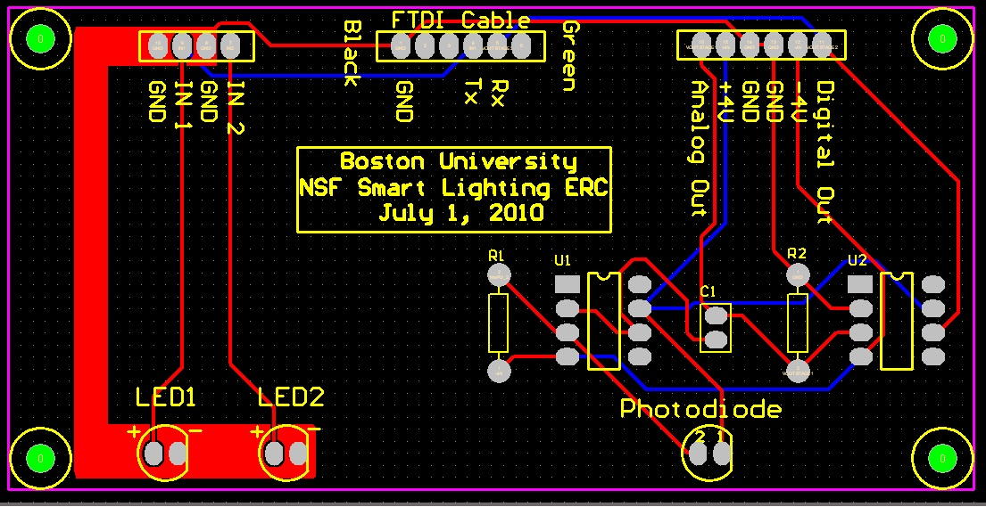

Workflow:
- Insert the parts from the top (silkscreened) side of the board
- When inserting parts with long leads: you can bend them to hold them in place
- For IC sockets, it helps to do them one at a time
- Turn the board over to solder
- When soldering, make sure to do so within the circuit lines.
- Trim long leads close to the board.
- Have one of the instructors check your board for shorts
- Populate the IC sockets with the associated ICs
- You are done!

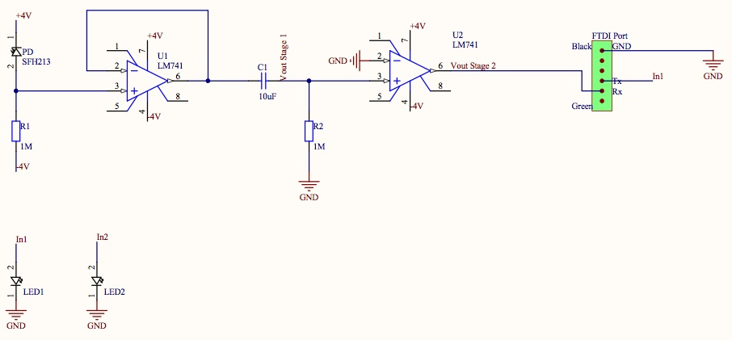

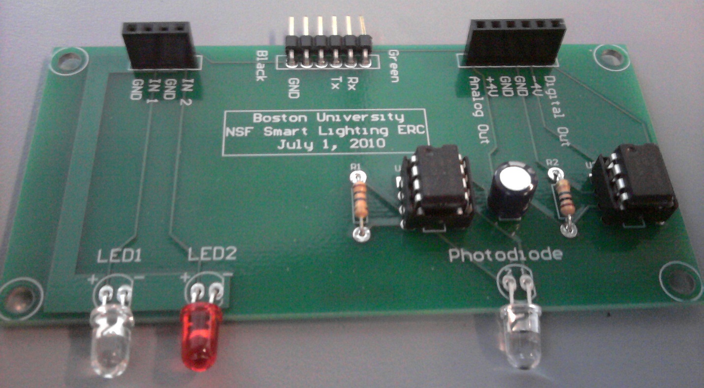
Lab Module 7: Signaling Using Light: Modulating Analog Signals

Objective: This lab is about modulating light in order to transmit information. Here the focus is on analog signals

Background reading

- Analog signals: http://en.wikipedia.org/wiki/Analogue_signal
- Amplitude modulation: http://en.wikipedia.org/wiki/Amplitude_modulation
- Frequency Modulation: http://en.wikipedia.org/wiki/Frequency_modulation
- Carrier wave: http://en.wikipedia.org/wiki/Carrier_wave
- Modulation: http://en.wikipedia.org/wiki/Modulation

Overview
- Modulation of light with signal (lab)
- AM modulation
- FM modulation
- Digital vs analog communication (e.g. digital TV)

Rhett Board and Mobile Studio Setup:
- Find two adjacent computers in the lab. Log into a machine next to your teammate(s).
- Setup your Rhett boards as in Module 1

Team Exercises
- Setup:
  - Setup each Transceiver on their own computer using a Rhett Board. Use the AWG1 and AGND pins to connect to pins labeled “IN 1” and “GND”, respectively on the transceiver. Connect the “+4V” and “-4V” of the transceiver to the matching pins on the Rhett Board.

  - Setup each transceiver by connecting the A1+ and AGND pins to “Analog Out” and “GND”, respectively.
  - Using the Arbitrary Waveform Generator, produce a sine wave at 5kHz with 1.5V peak-to-peak and 2.5V offset. This will drive a sine wave as an optical output.
  - Enable the oscilloscope on channel 1 (both computers)

- Measurement
  - Point the Transceivers at each other at a distance of approximately 1m. You should be able to see the optical waveform on the oscilloscopes.
  - Characterize the performance of your transceivers (both directions)
    - How fast can it go? (Attenuation at different frequencies.)
    - What is its range? (Attenuation at different distances.)
    - What is the field of view? (Attenuation at different angles from centerline.)
  - Experiment with lenses, reflectors, etc.
  - Observations? Performance?

- Transmitting a real audio file
  - Load the Spring Peepers .wav file into AWG
  - Look at the waveform on the display – identify appropriate DC offsets and scale factors to fit into your signal design range
  - Listen to the file at both source and destination
  - Observations? What happens if you increase the distance between the LED and PD?
  - Try a DC offset of 3V, how is this different?

- Try communicating to one of the other team’s boards (not yours, but some other team’s)
  - What happens when two signals are received by one board?
  - Experiment and record your results.

- Design Questions and Discussion
  - Compare our scheme to music system components – equalization, dynamic range, frequency response
  - How useful is a system in which volume is affected by distance?
  - How fast can we modulate the data on the system?
  - What are the factors that limit high data rates?
  - What are your conclusions about how you might design a system to modulate for highest data rates?

- Amplitude Modulation
  - Can you design a mechanism to achieve amplitude modulation?

Discussion and Wrap up:
- Be prepared to discuss your group’s results with the class.
- Update your log books.

Lab Module 8: Signaling Using Light: Digital Data Transmission

Objective: This lab is about modulating light in order to transmit information. Here we focus on digital techniques.

Background reading

- Heliograph: http://en.wikipedia.org/wiki/Heliograph
- Flag Semaphore: http://en.wikipedia.org/wiki/Flag_semaphore
- Code: http://en.wikipedia.org/wiki/Code
- On-Off Keying: http://en.wikipedia.org/wiki/On-off_keying
- Morse Code: http://en.wikipedia.org/wiki/Morse_code
- Modulation: http://en.wikipedia.org/wiki/Modulation
- Manchester Code: http://en.wikipedia.org/wiki/Manchester_code
- Pulse Position Modulation: http://en.wikipedia.org/wiki/Pulse-position_modulation
- Exclusive Or: http://en.wikipedia.org/wiki/Exclusive_or
- ASCII Table: http://en.wikipedia.org/wiki/ASCII

Overview
- What is coding?
- Coding types for light
- ASCII to Hex to Bin
- Sync bits and framing

In the lab we will establish communication using the following techniques
- Introduced carrier
  - Square wave
  - Biased square wave – LED always ‘on’
- OOK
  - Data added to signal
  - Manchester encoding – data on carrier made regular

Rhett Board and Mobile Studio Setup:
- Find two adjacent computers in the lab. Log into a machine next to your teammate(s).
- Setup your Rhett boards as in Module 1

Team Exercises
- Setup
  - Setup your LED on one Rhett Board using the AWG1 and AGND pins
  - Separate the boards by 1m
  - Using the Arbitrary Waveform Generator, produce square wave at 1kHz and full range signal.
  - Setup the second Rhett Board using a photodiode circuit as shown in the schematic of Module 4.
  - Connect the photodiode circuit to the SE1 and AGND pins and enable the oscilloscope on channel 1

- OOK Investigation
  - You are now modulating using a 1kHz carrier. Under OOK, the data stream is a series of 1s and 0s
  - Explore the limits of OOK to transmit this pattern (range, angles, intensities)
  - Identify the DC offset for the highest peak-to-peak voltage at the sender (LED side)

- OOK with 0101 sequence (balanced): We have created an arbitrary waveform representing a bit stream of 1 and 0. This is called OOK1.csv.
  - Load this using the AWG and use this to modulate the signal.
  - Compare the results to the previous exercise

- OOK with 110110 sequence (unbalanced)
  - Load the OOK2.csv file. This file has a repeating 110 bit pattern
  - Can you sync on this signal at the other end?
  - What is the problem with this kind of OOK modulation and the use of light?

- Manchester Encoding – using XOR chip (74LS86) and the red LED
  - Setup the XOR circuit on the breadboard (see illustration)
  - Use AWG1 as the clock (2 kHz square wave at 4V peak-to-peak) and AWG2 as the data channel (1 kHz square wave at 4V peak-to-peak).
  - Explore the output of this circuit
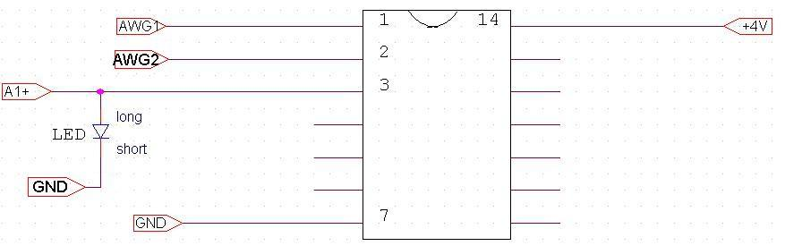
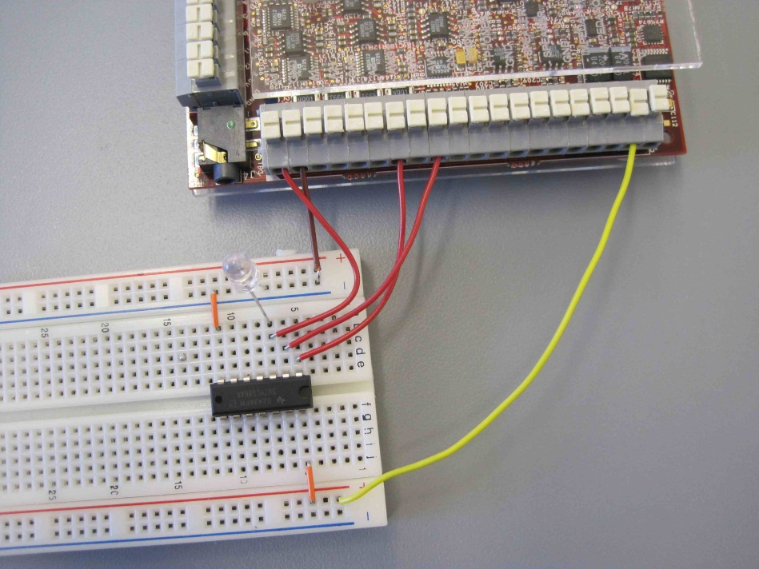

- Send a data file
  - Load the file OOK2.csv into the AWG. This file has two channels – clock and data in 110 pattern. The clock is twice the data rate.
  - Send the clock to AWG1, data to AWG2
  - Display the outputs on the oscilloscope to verify
  - What is wrong with the waveform? This is the XOR (Manchester-encoded data).
  - Can you detect the data at the receiver?

- Optional Manchester Encoding (logical)
  - Manchester encoding (and decoding) consists of an exclusive-OR (XOR) of the data stream with a clock operating at twice the source data bit rate. This means that in this simplest form, the data rate is reduced. The benefit is that the data become ‘self clocking’ and are balanced between logic states.
  - Using the Encoding.xls file, explore the translations of a bitstream from ASCII data to binary and to Manchester code.
  - What is the bit pattern for the text ‘LED’ in ASCII translated to Manchester code?

- Optional Design Problems
  - The Manchester encoding scheme provided is primitive. Can you think for ways to improve this circuit?
  - What are the factors that limit high data rates?
  - What are your conclusions about how you might design a system to modulate for highest data rates?

Lab Module 9: Texting with the Transceiver

Objective: Here we will use the transceiver that was populated earlier in the course. The goal here is to incorporate data transmission using the digital transceivers between two computers to enable digital transmission.

Background reading
- PuTTY: http://en.wikipedia.org/wiki/PuTTY
- FTDI serial cable: http://www.ftdichip.com/Products/EvaluationKits/TTL-232R.htm

We will explore two scenarios: (1) Driving the transceiver using the Rhett Board to understand performance; and (2) driving the transceiver using a USB to serial cable (manufactured by FTDI).

Rhett Board and Mobile Studio Setup:

- Find two adjacent computers in the lab. Log into a machine next to your teammate(s).
- Setup your Rhett boards as in Module 1

Team Exercises
- Setup part 1
  - Setup each transceiver to a computer and Rhett board. Connect the “+4V” and “-4V” of the transceiver to the matching pins on the Rhett Board. Connect grounds from the PCB to the Rhett(s)
  - Connect the USB to Serial cable to the Smart Light PCB being mindful of the color of the wires matching the indicators on the PCB silkscreen.
  - Make sure other connections are left open (no wires to Vout, Vin as in earlier lab)

- Setup part 2
  - DO NOT run Mobile Studio – not required.
  - On each computer, open (or install and open) PuTTY.
  - In the PuTTY Configuration, you need to change 2 categories: “Session” (top) and “Serial” (bottom)
    - You will need to determine which serial line (COM port) is provided by the FTDI cable. To find this, right-click on “My Computer”, scroll to “Properties”, click on “Device Manager”, and open “Ports (COM & LPT).” The serial line’s name will be something like COM##.
    - In the PuTTY configuration window, select “Serial” as the connection type.
    - Enter the serial line’s name (e.g., COM6) under “Serial line”.
    - Switch to the “Connection -> Serial” category by clicking “Serial” on the left hand side.

    - In this “Connection -> Serial” configuration category, change “Flow Control” to “None”.
    - Good work! You have set up your FTDI cable. Now to actually put it to use…
  - Open PuTTY by clicking the “Open” button. What do you see when you point the LED at the photodiode? What happens when you play around with the frequency applied to PWM1?
  - Try using light from the computer mouse on the receiver. What happens in the putty screen?
  - Connect each transceiver to the computer via the USB to serial cables provided.

- Communicating with Another Board
  - With the LED turned on and the boards facing each other, type into your PuTTY screen. Notice that something should come up on your partner’s PuTTY screen.
  - Play around with the LED to photodiode signal in order to get an accurate message of what is typed.
  - You are doing wireless optical texting. Enjoy.

- Measurement
  - Investigate increasing data rates of the channel
  - Record performance: the onset of errors
  - What is the maximum speed of transmission that you can achieve? Under what conditions (distance, angle, lensing, etc.).

Lab Module 10: CD Spectrometer

Objective: The goal here is to construct a simple spectrometer from a cardboard box and CD and to observe the characteristics of various light sources.

Background reading
- Spectrum: http://en.wikipedia.org/wiki/Electromagnetic_spectrum
- Spectrometer: http://en.wikipedia.org/wiki/Spectrometer
- CD Spectrometer: http://www.cs.cmu.edu/~zhuxj/astro/html/spectrometer.html

Constructing the spectrometer

Follow the instructions at the link above.

Team Exercises
- Measurement
  - Investigate the light sources in the room
    - LEDs of different colors
    - Mouse light
    - Fluorescent lighting
    - Sunlight
- Design
  - Why would it be useful to isolate or target a particular color for use in communications?
  - How could we do that?

Lab Module 11: Acoustic Heart Monitor

Objective: This lab is about operational amplifiers and building a device capable of detecting your heartbeat.

Background reading
- Loudspeaker: http://en.wikipedia.org/wiki/Loudspeaker
- Operational amplifier: http://en.wikipedia.org/wiki/Operational_amplifier
- Op Amp applications:
http://en.wikipedia.org/wiki/Operational_amplifier_applications
- Sound Amplification: http://en.wikipedia.org/wiki/Sound_amplification
- Heart Rate: http://en.wikipedia.org/wiki/Heart_rate

Overview
- What is gain?
- Non-inverting amplifiers
- What is your heart rate (units)?

In this lab:
- Operational amplifiers (op-amps) are used to amplify a signal
- R2/R1 is the gain, or the amount the input signal is multiplied by
- The signal from your heart must be amplified in order to see a signal on the computer

Rhett Board and Mobile Studio Setup:
- Find a computer in the lab. Log into a machine with your teammate. Note: only one Computer/Rhett Board is required, and team members should work together.
- Setup your Rhett board as in Module 1

Team Exercises

- Using your speaker as a microphone
  - Setup the breadboard using a speaker/microphone circuit as shown below (don’t forget to power the op-amp with ±4V)
  - Using alligator clips if necessary, connect Pin 3 (in) from the op-amp to the positive (+) end of the speaker. Connect the negative (-) end of the speaker to AGND.
  - Connect Pin 6 (out) from the op-amp to A1.
  - Turn on the oscilloscope.
  - Speak into the microphone and see if you can see a signal (you may need to play around with the Volts/Div and Time/Div in order to see a clear signal; try decreasing the Time/Div).
    - NOTE: Not all the speakers are the same, so you may not have the same combination of R2 and R1 as your neighbors.
  - (Optional) Try to measure the average zero-to-peak amplitude of the voltage produced by the microphone.

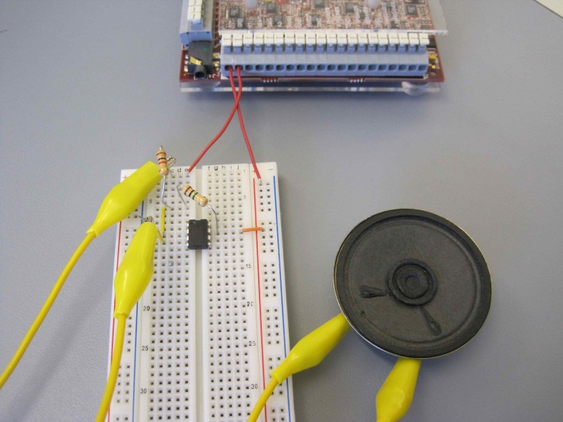

- Listening to your heartbeat
  - Once you are happy with your circuit, place the speaker over your chest cavity, choosing a convenient position that picks up your heartbeat. Alternatively, you can place the loudspeaker in the crook of your neck, near the carotid artery where a pulse is felt. You may have to experiment with several different positions to pick up a good acoustic signal, and you may have to remain quiet and still because the microphone will be very sensitive to movement.
  - Observe your heartbeat with the oscilloscope. You will see lots of electrical noise from the amplifier output, but the heartbeat should be observable as a regular pulse superimposed on the noise.
  - Collaborate with another group, use multiple op-amps, and play around with the resistors used in order to get a large enough gain (amplification).
    - NOTE: After a certain amount of amplification, the signal cuts off. This means that the oscilloscope cannot read the saturated signal above a certain voltage (~9V).
  - Use the oscilloscope to try to measure the beating rate of your heart (period, frequency, heart rate, etc.). Take a screen shot of the best signal you can find.
    - NOTE: It may help to do some exercise to increase the strength of your heart’s acoustic signature. You can do jumping jacks in place, for example, run up and down the hallway, or climb up and down the atrium stairs between floors 1 and 2 in the Photonics building before returning to your lab station. (In a previous class, one group ran all the way to the 9th floor and back.)
  - Plug in the headphones to the stereo jack and enable audio.
  - You may or may not be able to observe the “lub-dub” sound of your heartbeat. For example, I heard music from a radio station (Why?).

Presentations

Objective: To give an uninitiated audience an understanding of the problem that we worked on, the technical challenges, and how we overcame those challenges.

Each student should prepare a single slide corresponding to a topic covered in a class module. The topics will be assigned by the instructor.

Tips on creating the slides
- Your goal is to explain to your audience something that is new to them.
- Illustrations, photos, graphs and other visuals are effective.
- A table is less effective, and should be used judiciously.
- Text is usually a bad idea. If absolutely necessary, use a bullet with a very short phrase. There should never be more than 10-15 words on a slide.

Tips on presenting
- Do not read from the slide
- Practice aloud beforehand and learn to maintain a correct pace

Appendix

Resistor Color Codes
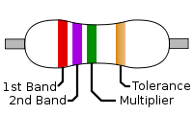
Color | Significant  figures | Multiplier | Tolerance |  | Temp. Coefficient (ppm/K)
Black | 0 | ×10⁰ | – |  | 250 | U
Brown | 1 | ×10¹ | ±1% | F | 100 | S
Red | 2 | ×10² | ±2% | G | 50 | R
Orange | 3 | ×10³ | – |  | 15 | P
Yellow | 4 | ×10⁴ | (±5%) | – | 25 | Q
Green | 5 | ×10⁵ | ±0.5% | D | 20 | Z
Blue | 6 | ×10⁶ | ±0.25% | C | 10 | Z
Violet | 7 | ×10⁷ | ±0.1% | B | 5 | M
Gray | 8 | ×10⁸ | ±0.05% (±10%) | A | 1 | K
White | 9 | ×10⁹ | – |  | –
Gold | – | ×10⁻¹ | ±5% | J | –
Silver | – | ×10⁻² | ±10% | K | –
None | – | – | ±20% | M | –

